**Practical No. 11**

**Title: Design web application with the help of node js, express, body parser, express-session and mysql**

**Aim:** To Design web application with the help of node js, express, body parser, express-session and mysql

**Step 1: Open XAMPP**

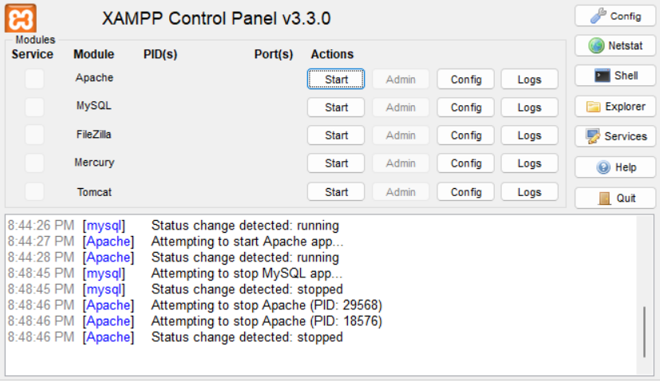

**Step 2: Run MySql in it**

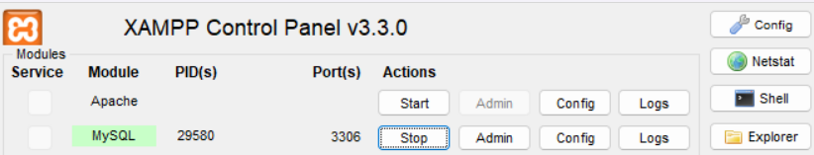

**Step 3: Create contactform.sql database, run cmd > node index.js file**

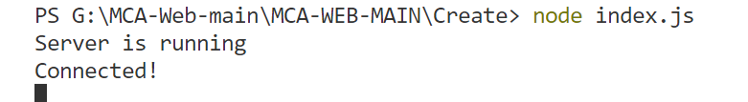

**Step 4: Create login.html**

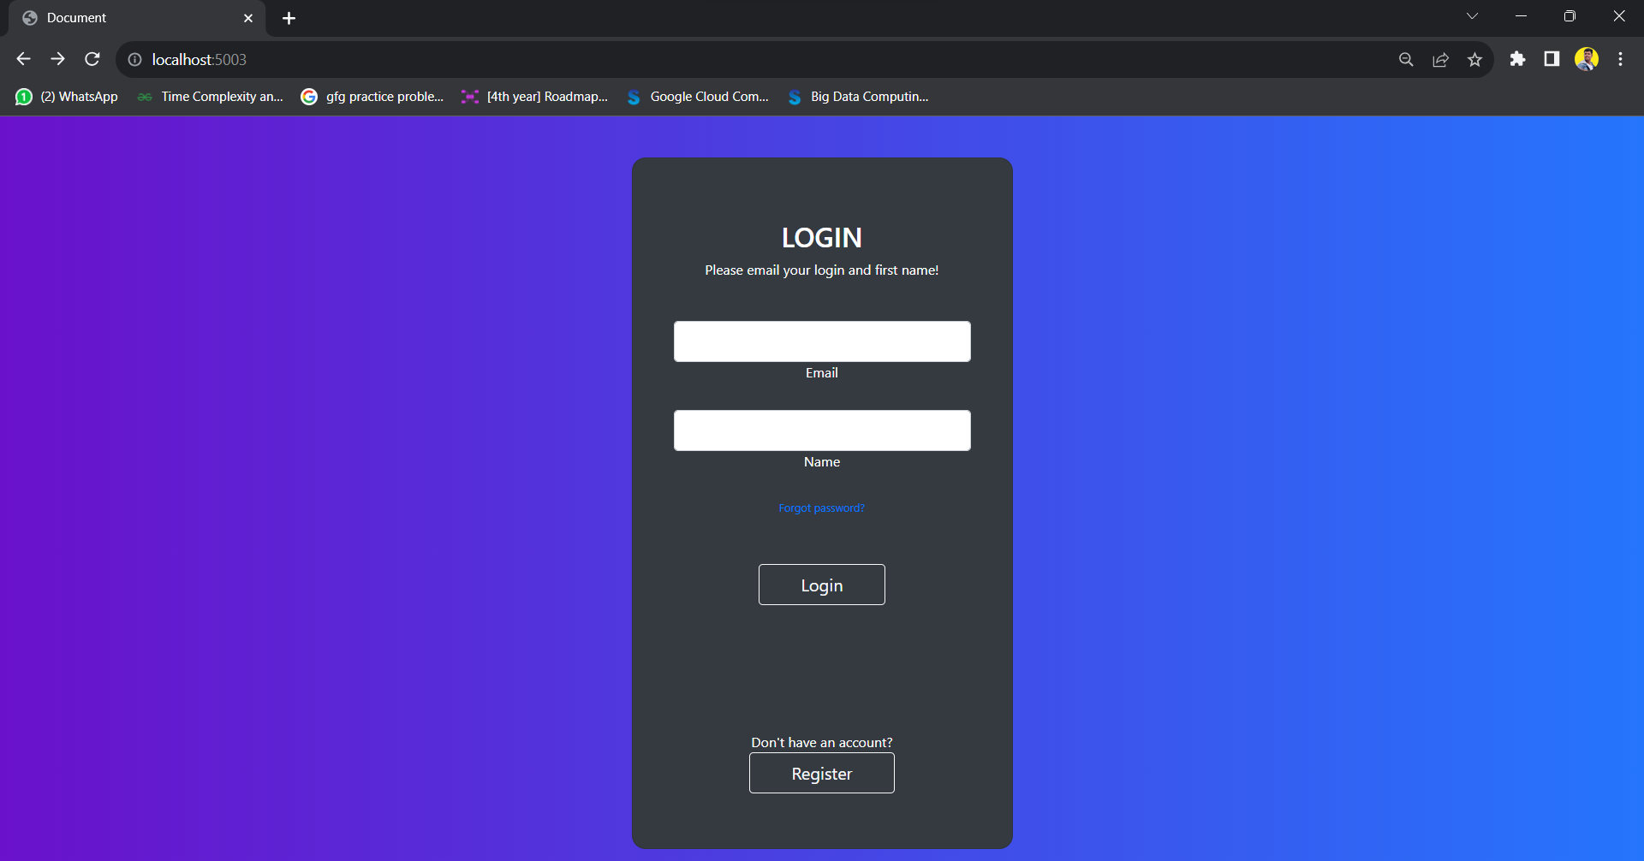

**Step 4: Create Registration Page**

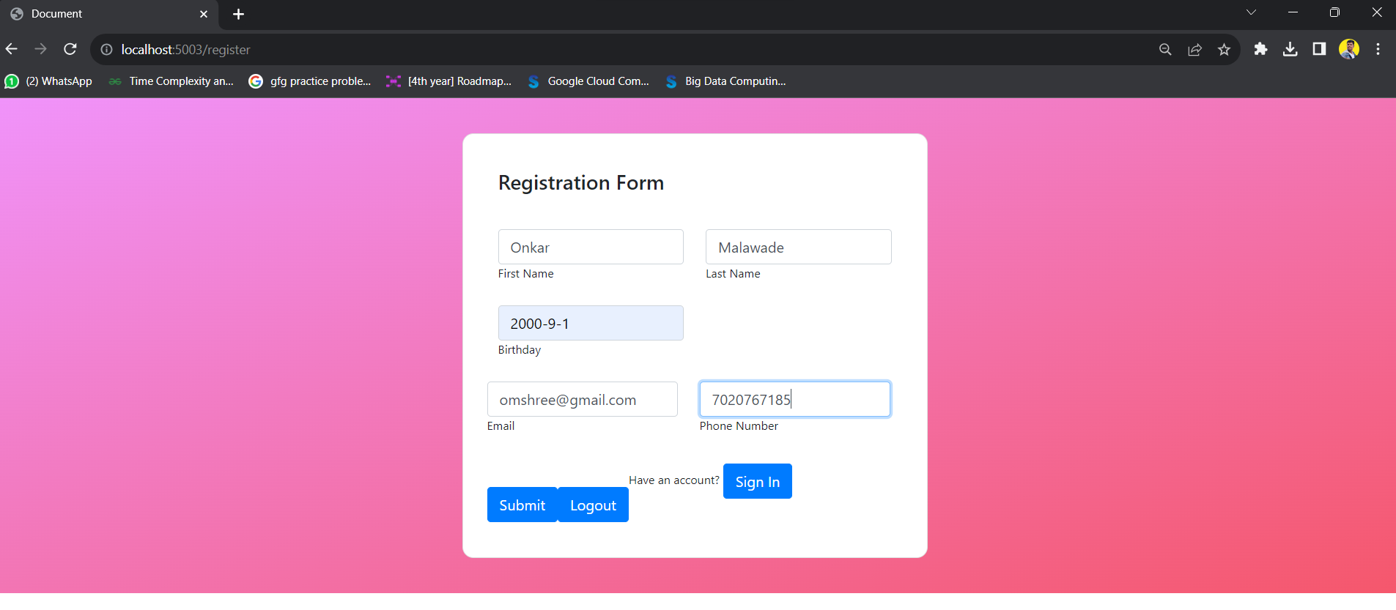

**Step 5: Create Database with Structure**

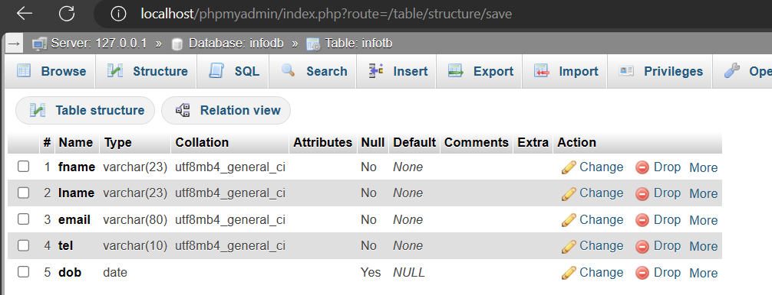

**Step 6: Insert Value in the Table Because we will do code that says if you have the account you will add another person to it.**

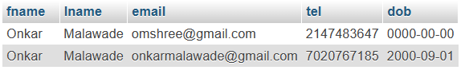

**Index.js:**

var express = require('express');

var mysql = require('mysql');

var db=require('./database');

var session = require('express-session');//session

var flash = require ('express-flash');//flash

var app = express();

var bodyParser = require('body-parser');

//const { stringify } = require('querystring');

app.use(bodyParser.json());

app.use(bodyParser.urlencoded({ extended: true }));

app.use(flash());

app.use(session({

   secret: '123456cart',

   resave: false,

   saveUninitialized: true,

   cookie:{ maxAge: 60000}

}))

app.get('/', function(req, res){

    res.sendFile(__dirname+'/login.html');

  });

app.post('/auth',function(req,res){

   let email = req.body.email;

   let fname = req.body.fname;

   if(email && fname){

      db.query('Select * from infoTB where fname = ? and email = ?',[fname,email],function(error,results){

         if(error) throw error;

         if(results.length > 0){

            req.session.loggedin = true;

            req.session.fname=fname;

            res.redirect('/register');

         }else{

            res.send('Incorrect UserEmail or Username');

         }

         res.end();

      });

   }else{

      res.send('Please enter UserEmail and Password');

      res.end();

   }

});

app.get('/register',function(req,res){

   if (req.session.loggedin) {

      res.sendFile(__dirname+'/new.html');

   } else {

      res.send('Please Login to view the Page');

   }

});

app.post('/formSubmit', function(req, res){

  if(req.session.loggedin){

   //res.send(JSON.stringify("Hello "+req.body.name+" "+req.body.surname));

   var f_name = req.body.fname;

   var l_name = req.body.lname;

   var email = req.body.email;

   var tel = req.body.tel;

   var dob = req.body.dob;

   var sql = `INSERT INTO  infoTB(fname,lname,email,tel,dob)VALUES("${f_name}","${l_name}","${email}","${tel}","${dob}")`;

   db.query(sql,function(err,result){

      if (err) throw err;

      console.log("record inserted");

      req.flash('success','Data added succefully');

   });

   }else{

      res.send('Please send login view');

   }

    res.redirect('/register');

    res.end();

    });

app.post('/logout',function(req,res){

   req.session.destroy((err) =>{

      res.redirect('/');

   })

});

app.post('/reg',function(req,res){

   req.session.destroy((err) =>{

      res.redirect('/register');

   })

});

app.post('/loged',function(req,res){

   req.session.destroy((err) =>{

      res.redirect('/');

   })

});

app.listen(5003,()=>{

   console.log("Server is running")

});

**Database.js**

var mysql = require('mysql');

var con = mysql.createConnection({

  host: "localhost",

  user: "root",

  password: "",

  database:"infoDB"

});

con.connect(function(err) {

  if (err) throw err;

  console.log("Connected!");

});

module.exports=con;

**Login.html**

<!DOCTYPE html>

<html lang="en">

<head>

    <meta charset="UTF-8">

    <meta name="viewport" content="width=device-width, initial-scale=1.0">

    <link rel="stylesheet" href="https://cdn.jsdelivr.net/npm/bootstrap@4.0.0/dist/css/bootstrap.min.css" integrity="sha384-Gn5384xqQ1aoWXA+058RXPxPg6fy4IWvTNh0E263XmFcJlSAwiGgFAW/dAiS6JXm" crossorigin="anonymous">

    <script src="https://code.jquery.com/jquery-3.2.1.slim.min.js" integrity="sha384-KJ3o2DKtIkvYIK3UENzmM7KCkRr/rE9/Qpg6aAZGJwFDMVNA/GpGFF93hXpG5KkN" crossorigin="anonymous"></script>

<script src="https://cdn.jsdelivr.net/npm/popper.js@1.12.9/dist/umd/popper.min.js" integrity="sha384-ApNbgh9B+Y1QKtv3Rn7W3mgPxhU9K/ScQsAP7hUibX39j7fakFPskvXusvfa0b4Q" crossorigin="anonymous"></script>

<script src="https://cdn.jsdelivr.net/npm/bootstrap@4.0.0/dist/js/bootstrap.min.js" integrity="sha384-JZR6Spejh4U02d8jOt6vLEHfe/JQGiRRSQQxSfFWpi1MquVdAyjUar5+76PVCmYl" crossorigin="anonymous"></script>

<style>

    .gradient-custom {

/* fallback for old browsers */

background: #6a11cb;

/* Chrome 10-25, Safari 5.1-6 */

background: -webkit-linear-gradient(to right, rgba(106, 17, 203, 1), rgba(37, 117, 252, 1));

/* W3C, IE 10+/ Edge, Firefox 16+, Chrome 26+, Opera 12+, Safari 7+ */

background: linear-gradient(to right, rgba(106, 17, 203, 1), rgba(37, 117, 252, 1))

}

</style>

<title>Document</title>

</head>

<body>

    <section class="vh-100 gradient-custom">

        <div class="container py-5 h-100">

          <div class="row d-flex justify-content-center align-items-center h-100">

            <div class="col-12 col-md-8 col-lg-6 col-xl-5">

              <div class="card bg-dark text-white" style="border-radius: 1rem;">

                <div class="card-body p-5 text-center">

                  <div class="mb-md-5 mt-md-4 pb-5">

                    <h2 class="fw-bold mb-2 text-uppercase">Login</h2>

                    <p class="text-white-50 mb-5">Please email your login and first name!</p>

                    <form action="/auth" method="post">

                    <div class="form-outline form-white mb-4">

                      <input type="email" name="email" id="typeEmailX" class="form-control form-control-lg" />

                      <label class="form-label" for="typeEmailX">Email</label>

                    </div>

                    <div class="form-outline form-white mb-4">

                      <input type="text" name="fname" id="typePasswordX" class="form-control form-control-lg" />

                      <label class="form-label" for="typePasswordX">Name</label>

                    </div>

                    <p class="small mb-5 pb-lg-2"><a class="text-white-50" href="#!">Forgot password?</a></p>

                    <button class="btn btn-outline-light btn-lg px-5" type="submit">Login</button>

                </form>

                    <div class="d-flex justify-content-center text-center mt-4 pt-1">

                      <a href="#!" class="text-white"><i class="fab fa-facebook-f fa-lg"></i></a>

                      <a href="#!" class="text-white"><i class="fab fa-twitter fa-lg mx-4 px-2"></i></a>

                      <a href="#!" class="text-white"><i class="fab fa-google fa-lg"></i></a>

                    </div>

                  </div>

                  <div>

                    <p class="mb-0">Don't have an account? <form action="/reg" method="post"><button class="btn btn-outline-light btn-lg px-5" type="submit">Register</button></form>

                    </p>

                  </div>

                </div>

              </div>

            </div>

          </div>

        </div>

      </section>

</body>

</html>

**New.html**

<!DOCTYPE html>

<html lang="en">

<head>

    <meta charset="UTF-8">

    <style>

        .gradient-custom {

/* fallback for old browsers */

background: #f093fb;

/* Chrome 10-25, Safari 5.1-6 */

background: -webkit-linear-gradient(to bottom right, rgba(240, 147, 251, 1), rgba(245, 87, 108, 1));

/* W3C, IE 10+/ Edge, Firefox 16+, Chrome 26+, Opera 12+, Safari 7+ */

background: linear-gradient(to bottom right, rgba(240, 147, 251, 1), rgba(245, 87, 108, 1))

}

.card-registration .select-input.form-control[readonly]:not([disabled]) {

font-size: 1rem;

line-height: 2.15;

padding-left: .75em;

padding-right: .75em;

}

.card-registration .select-arrow {

top: 13px;

}

    </style>

    <meta name="viewport" content="width=device-width, initial-scale=1.0">

    <link rel="stylesheet" href="https://cdn.jsdelivr.net/npm/bootstrap@4.0.0/dist/css/bootstrap.min.css" integrity="sha384-Gn5384xqQ1aoWXA+058RXPxPg6fy4IWvTNh0E263XmFcJlSAwiGgFAW/dAiS6JXm" crossorigin="anonymous">

    <script src="https://code.jquery.com/jquery-3.2.1.slim.min.js" integrity="sha384-KJ3o2DKtIkvYIK3UENzmM7KCkRr/rE9/Qpg6aAZGJwFDMVNA/GpGFF93hXpG5KkN" crossorigin="anonymous"></script>

<script src="https://cdn.jsdelivr.net/npm/popper.js@1.12.9/dist/umd/popper.min.js" integrity="sha384-ApNbgh9B+Y1QKtv3Rn7W3mgPxhU9K/ScQsAP7hUibX39j7fakFPskvXusvfa0b4Q" crossorigin="anonymous"></script>

<script src="https://cdn.jsdelivr.net/npm/bootstrap@4.0.0/dist/js/bootstrap.min.js" integrity="sha384-JZR6Spejh4U02d8jOt6vLEHfe/JQGiRRSQQxSfFWpi1MquVdAyjUar5+76PVCmYl" crossorigin="anonymous"></script>

    <title>Document</title>

</head>

<body>

    <section class="vh-100 gradient-custom">

        <div class="container py-5 h-100">

          <div class="row justify-content-center align-items-center h-100">

            <div class="col-12 col-lg-9 col-xl-7">

              <div class="card shadow-2-strong card-registration" style="border-radius: 15px;">

                <div class="card-body p-4 p-md-5">

                  <h3 class="mb-4 pb-2 pb-md-0 mb-md-5">Registration Form</h3>

                  <form action="/formSubmit" method="post">

                    <div class="row">

                      <div class="col-md-6 mb-4">

                        <div class="form-outline">

                          <input type="text" id="firstName" name="fname" class="form-control form-control-lg" />

                          <label class="form-label" for="firstName">First Name</label>

                        </div>

                      </div>

                      <div class="col-md-6 mb-4">

                        <div class="form-outline">

                          <input type="text" id="lastName" name="lname" class="form-control form-control-lg" />

                          <label class="form-label" for="lastName">Last Name</label>

                        </div>

                      </div>

                    </div>

                    <div class="row">

                      <div class="col-md-6 mb-4 d-flex align-items-center">

                        <div class="form-outline datepicker w-100">

                          <input type="text" name="dob" class="form-control form-control-lg" id="birthdayDate" />

                          <label for="birthdayDate" class="form-label">Birthday</label>

                        </div>

                      </div>

                      <div class="col-md-6 mb-4">

                        </div>

                    <div class="row">

                      <div class="col-md-6 mb-4 pb-2">

                        <div class="form-outline">

                          <input type="email" name="email" id="emailAddress" class="form-control form-control-lg" />

                          <label class="form-label" for="emailAddress">Email</label>

                        </div>

                      </div>

                      <div class="col-md-6 mb-4 pb-2">

                        <div class="form-outline">

                          <input type="tel" name="tel" id="phoneNumber" class="form-control form-control-lg" />

                          <label class="form-label" for="phoneNumber">Phone Number</label>

                        </div>

                      </div>

                    </div>

                    <div class="mt-4 pt-2">

                      <input class="btn btn-primary btn-lg" type="submit" value="Submit" />

                    </div>

                  </form>

                  <form action="/logout" method="post">

                  <div class="mt-4 pt-2">

                    <input class="btn btn-primary btn-lg" type="submit" value="Logout" />

                  </div>

                </form>

                  <div><form action="/loged" method="post">

                    <p class="mb-0">Have an account? <input class="btn btn-primary btn-lg" type="submit" value="Sign In" />

                    </p></form>

                  </div>

                </div>

              </div>

            </div>

          </div>

        </div>

      </section>

</body>

</html>

**Here is Simple Flow Chart Of the Given Code:**

